Running head: Catch Billy

Catch Billy Miner

By

Trevor Pasanen
University of Alberta

Krista Francis-Poscente
University of Calgary

November 6, 2012

Key Words: Problem Solving, 2 person game, Grades 4-6, Number Sense, Pattern

Correspondence regarding this article should be sent to Trevor Pasanen, University of Alberta, tpasanen@math.ualberta.ca

Catch Billy Miner
Are you looking for fresh ideas for challenging your students? Catch Billy Miner is a great game that you can play in class. We call this game unfair because there is a way to always win. By always winning you can have some fun with your students demonstrating your exceptional skills at game play. This game is suitable for many ages, but we focused this article for Grades 4-6. Once your students learn the winning strategy, they will have gained skills learning how to solve a problem with number and pattern.

The Catch Billy Miner Game
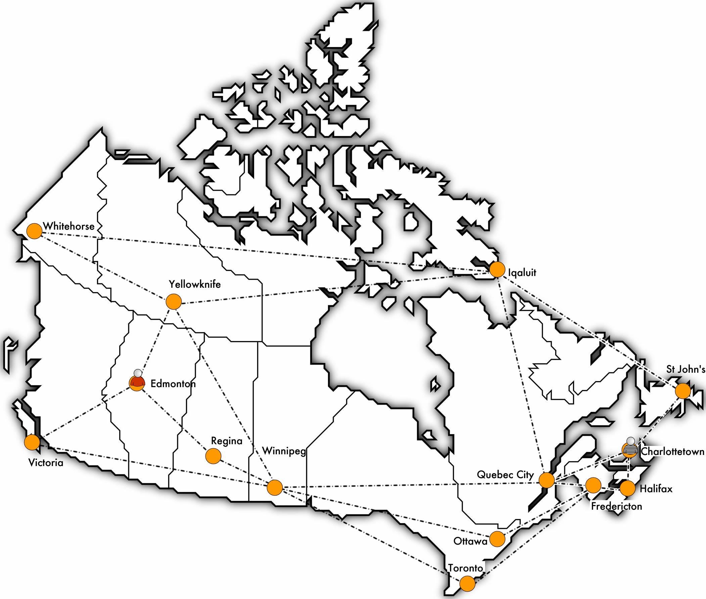
Figure 1: Starting positions on the game board

The Mountie starts in Edmonton and Billy Miner in Charlottetown. One player moves the Mountie and another moves Billy. A “move” consists of sliding the chip from one city to an adjacent city along the dashed line. The Mountie tries to capture Billy by moving onto the city occupied by Billy. Billy tries to evade imprisonment. If the Mountie captures Billy in 5 moves or less (that is five of Billy’s moves), then the Mountie wins. If the Mountie fails to capture Billy in 5 moves then Billy wins and the criminals take over Canada. The Mountie goes first.

Catch Billy Miner in the Classroom

One way to introduce this problem is with a SmartBoardTM. Load the template found in the appendix. Have two volunteers come up to the SmartBoardTM to demonstrate how to play the game. Assign one to be the North West Mounted Police and the other to be Billy Miner, the Robber. The Mountie goes first and tries to catch Billy. Once students understand the rules, hand out game boards (see the appendix) and small chips to represent the Mountie and Billy. They will be excited to play for several minutes.
Move around the classroom and challenge a child to a game. Be the Mountie and let them be Billy. Make sure you win. Ask them if it they think you were just lucky. Play enough times with a few children so that the buzz in the classroom will be that you know how to win.
When we played this game with children, they squealed with delight and exasperation each time we won. They begged us for our secret.
Someone in the class may figure out how to win. If they do, get them to come up to the front and explain their strategy. If not, play a student on the SmartBoardTM and win. Prompt the students to be observant. Many will notice that you always head to Yellowknife. Most will not notice your second and third moves.
On your second game on the SmartBoardTM, get the students to tell you how to move the Mountie. You will lose the game if they did not observe your second and third moves. Coach them to remember what was done last time and what could be different in the next game. Repeat this process until they have the strategy figured out.

Solution to the game

The solution to the problem is from graph theory and discrete mathematics. Graph theory and discrete mathematics is an emerging field with applications to computer programming. You won’t find Graph Theory or Discrete mathematics mentioned specifically in the Program of Studies (Alberta Education, 2007). However, there are many concepts that are encompassed by Graph Theory.
Graphs in the Program of Study are defined in terms of linear relations in Cartesian space positioned along the x and y axis. However, Graph Theory provides a different definition with abstract representation of objects connected by lines.
Definition : A graph is a collection of dots and lines, with every line terminated by a dot at each end. The dots are called vertices and the lines are called edges.

The graph below is a representation of the map above. Each city is represented as a vertex. Edges join the city.

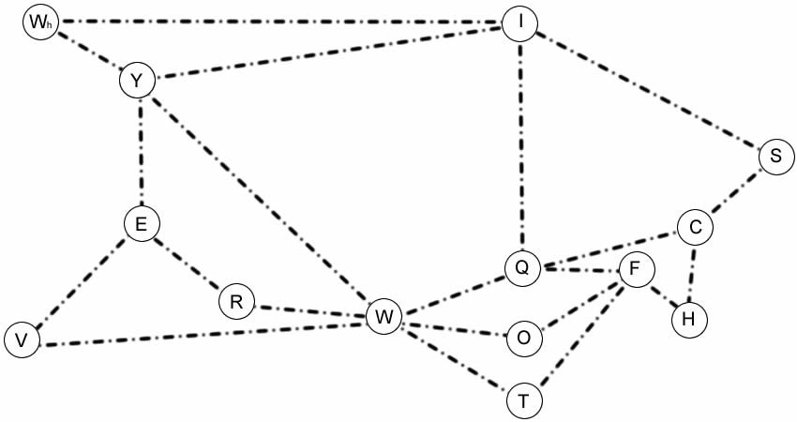
Figure 2: Graph of the game board
Colour Yellowknife yellow. Colour every city that is connected to Yellowknife purple. Colour the cities attached to those cities yellow. Keep going until the cities are yellow or purple.
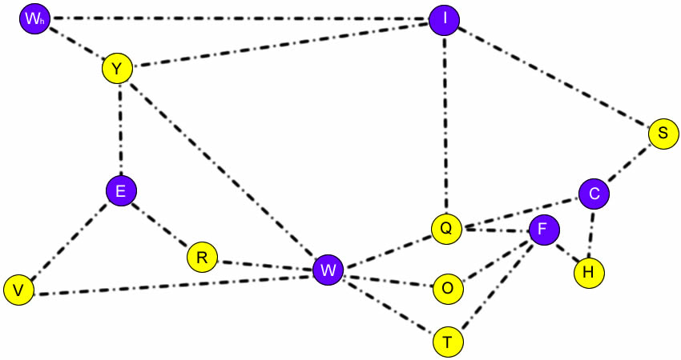
Figure 3: Color-coded graph of game board
Notice that all the loops between cities have four edges with the exception of the Yellowknife- Iqualit-Whitehorse loop. That loop has only three edges. Also notice that Whitehorse and Iqualit are adjacent and are both purple. Without four edges alternating colours is not possible.

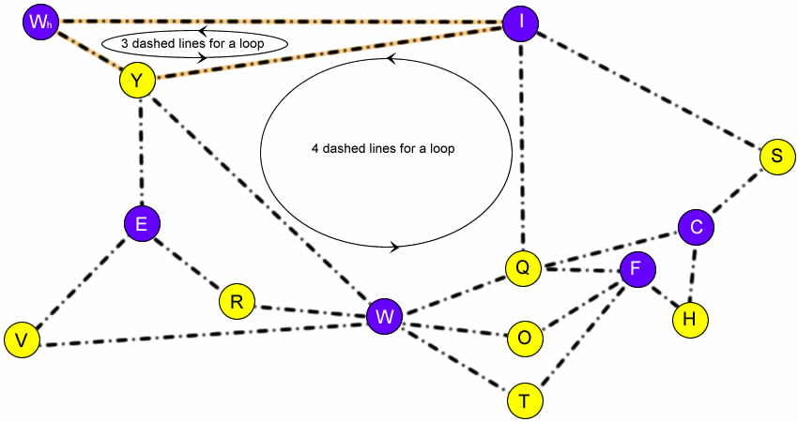
Figure 4: Loops between cities

The cities can be divided into purple and yellow groups.

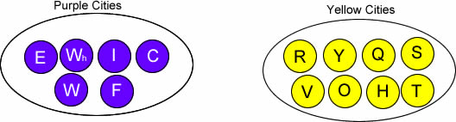
Figure 5: Cities that have purple vertices and cities that have yellow vertices

A common strategy for the unaware Mountie
Billy Miner starts in Charlottetown and the Mountie from the North West Mounted Police starts in Edmonton. If the Mountie moves to Regina and Winnipeg, Billy Miner will stay in the same coloured group as the Mountie.

Start:

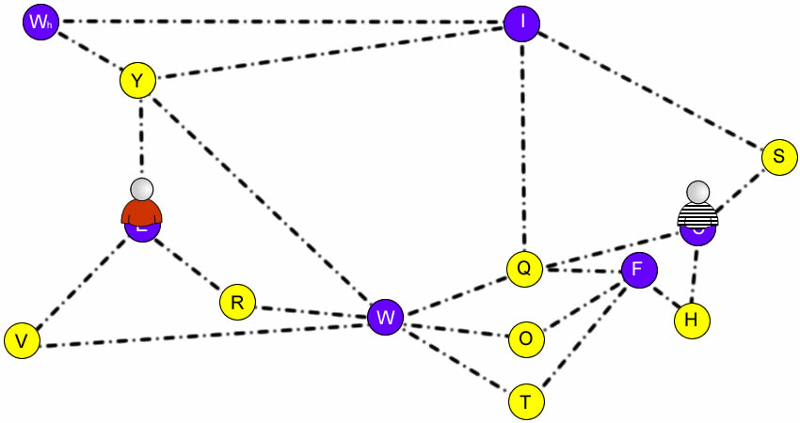
Figure 6: Start of the game

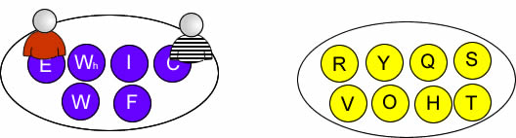
Figure 7: Billy the Miner and the Mountie are both on purple vertices

Move #1: The Mountie moves to Regina and Billy runs to Halifax. Both are in Yellow cities now.
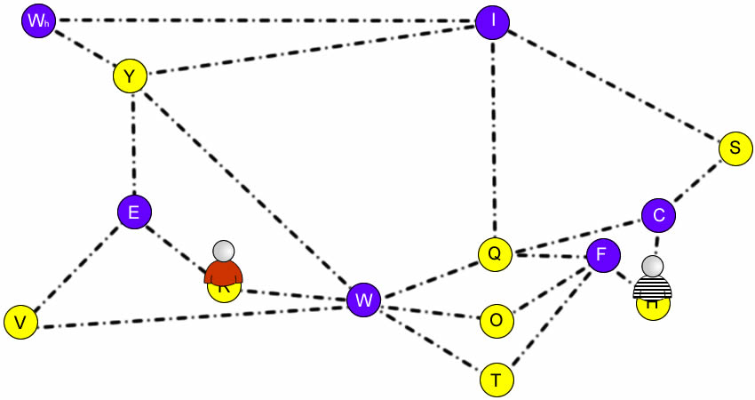
Figure 8: A possible first move
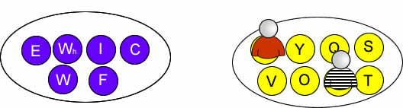
Figure 9: Billy and the Mountie are both on yellow vertices
Move #2: The Mountie moves to Winnipeg and Billy hides in Fredericton. Both are in Purple cities.
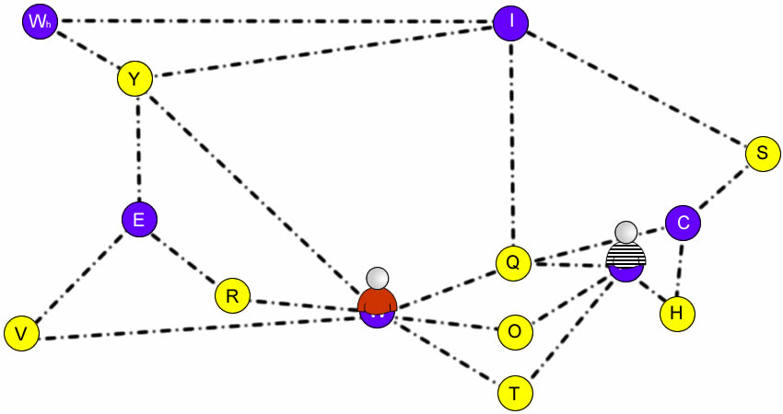
Figure 10: A possible third move
Move #3: The Mountie moves to Quebec City and Billy runs to Ottawa. Billy is free.
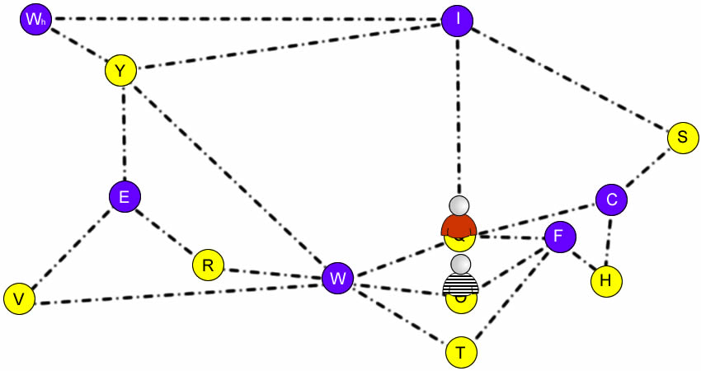
Figure 11: Still chasing Billy

Billy will always be safe from the Mountie if the Mountie stays in the loops with four edges. When the Mountie travels along the loops of four, Billy and the Miner will always be on the same coloured vertices. They will always have another vertex between them.

Unfair strategy for the aware Mountie

The situation changes if the Mountie moves from Whitehorse to Iqualit and into the loop with three vertices. Move #1: Instead of moving to Regina, the Mountie moves to Yellowknife.
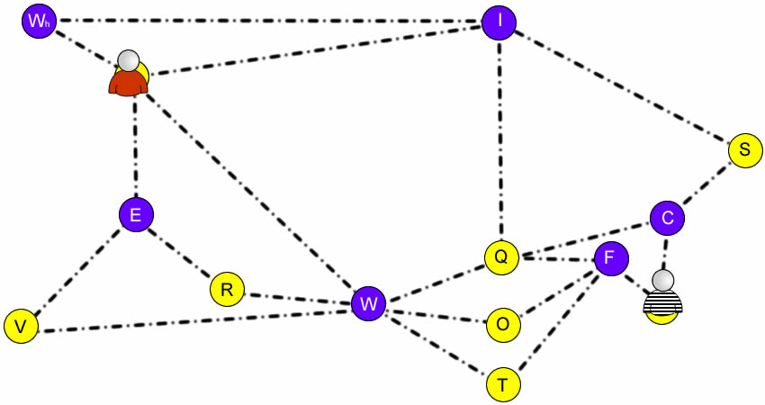
Figure 12: A different first move

Move #2: The Mountie moves to Whitehorse and Billy runs to Fredericton. Both are still in purple cities.

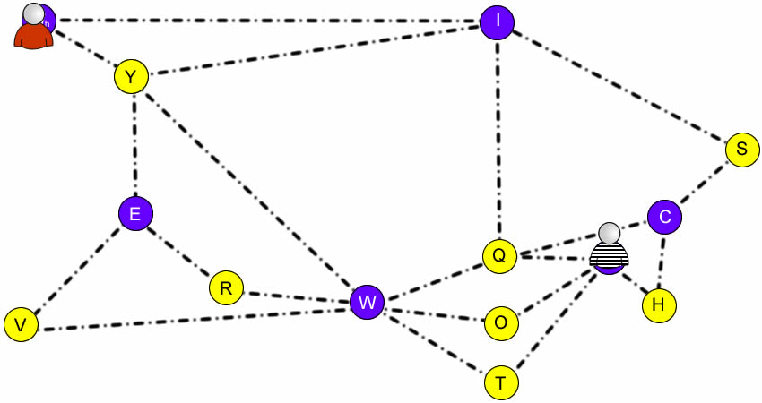
Figure 13: The next move. The Mountie is in the loop with three vertices.
Move #3: The Mountie moves to Iqualit and Billy moves to Ottawa. Notice the colour of the vertices. The Mountie is now on a purple vertex. Billy is on a yellow vertex.
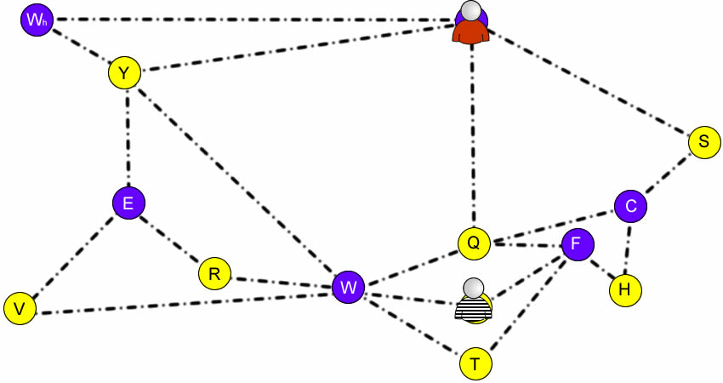
Figure 14: Move #3. The Mountie is in the loop with three vertices and has a different coloured vertex than Billy
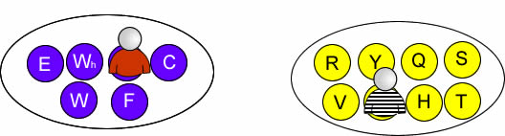

Figure 15: Billy and the Mountie are in different coloured cities.

Move #4: The Mountie moves to Quebec. Billy runs to Winnipeg.

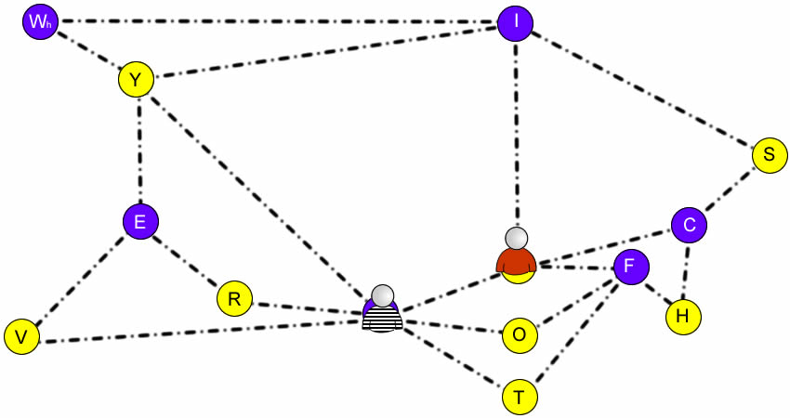
Figure 16: The Mountie can taste his victory
The Mountie catches Billy in the next move. By moving into the loop with three lines, the Mountie was able to occupy a city with a different colour than Billy Miner. Being on a different coloured city enabled the Mountie to get to an adjacent city.
How the Mountie can always win

The Mountie can always catch Billy in five or less moves. Surprisingly the most important move in this game is from Whitehorse to Iqaluit, think about what happens if the Mountie races to make that move. The Mountie starts the game by making the following three moves:

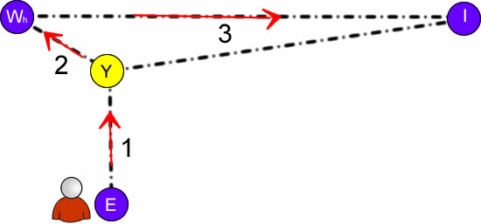
Figure 17: The Mountie can always win with these moves
Meanwhile, while avoiding the Mountie, Billy’s first three moves follow the pattern of going to a yellow city, then to a purple city, and then back to a yellow city. This means the Mounties fourth move starts in Iqaluit while Billy is in one the 8 yellow cities. Now, investigate each situation in three cases:

Case 1: Billy is in Quebec, St. Johns, or Yellowknife. In this case the Mountie moves towards Billy and catches him on the fourth move.
Case 2: Billy is in Halifax, Ottawa, or Toronto. In this case the Mountie’s fourth move is to Quebec City and Billy’s fourth move is to one of Winnipeg, Fredericton, or Charlottetown.
Finally, the Mountie moves towards Billy and catches him on the fifth move.
Case 3: Billy is in Regina or Victoria. In this case the Mountie’s fourth move is to Yellowknife and Billy’s fourth move is to Winnipeg or Edmonton. Again, the Mountie moves towards Billy and catches him on the fifth move.

Relevance to Program of Studies

The game of Catch Billy Miner addresses all of the mathematical process listed in the Program of Studies: communications, connections, mental estimations and mental mathematics, problem solving, reasoning, technology and visualization. Learning how to apply graph theory to win at a game is mathematical problem solving at its best. Strategic game play provides relevance and motivation to learn mathematical concepts.
Within the Grades 4 – 6 General Outcome: Develop Number Sense, this problem helps children develop mental strategies for solving problems. Understanding how a different sized loop changes the position of the Mountie relative to Billy involves number comparison and problem solving with whole numbers and integers. Within the Grades 4 – 6 General Outcome: use patterns to describe the world and solve problems, knowing how the Mountie can always win reinforces understanding of mathematical relationships within a chart to solve a problem. Similarly translating and applying rules for prediction are also reinforced. The following figure illustrates the relevant Specific Outcomes:
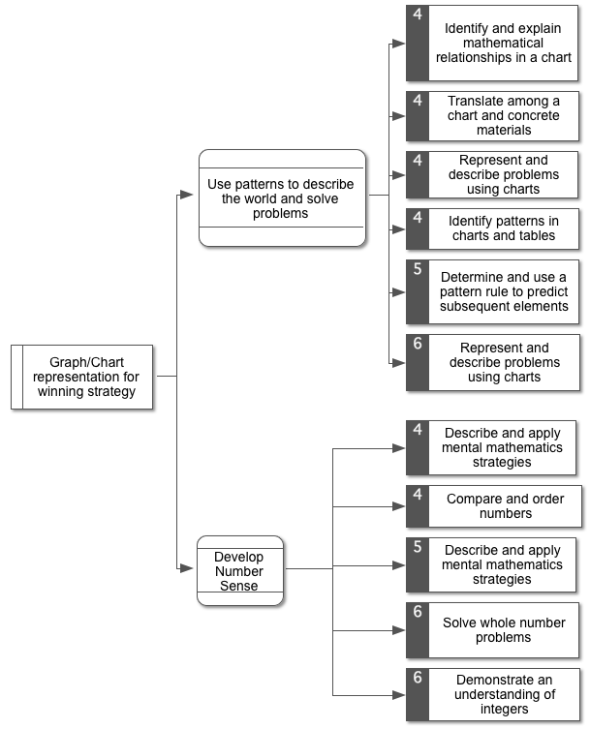
Figure 18: Relevant outcomes of Catch Billy Miner to the Alberta Program of Studies (2007)

There are opportunities for cross-curricular exploration. Notice that the cities are the capitals of Canada. Also Billy Miner was a famous stagecoach robber in the early 1900’s. Legend has it that Billy Miner was responsible for Canada’s first train robbery (Wikipedia contributors, 2012).

Problem Extension
Consider a different problem where only the Mountie moves through the map. Billy has set up a camp along one of the roads between two capital cities. The Mountie needs to find Billy’s camp by checking all the roads on the map. Billy may move his camp soon; there is only enough time for the Mountie to check each road once. Plan a route which guarantees that the Mountie will find Billy’s camp in time.

Extension Solution

Notice, there 12 cities with an even number of roads (call them even cities) but only two cities (Edmonton and Charlottetown) with an odd number of roads. When starting in an even city the Mountie will get stuck in Edmonton or Charlottetown before checking all the roads. For example consider the Mountie’s route starting in Winnipeg. The first pass through Edmonton would check 2 of the 3 roads:
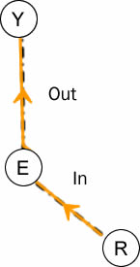
Figure 19: Edmonton start

Now, the Mountie does not want check the last road leading into Edmonton until all other roads are checked. But the first pass through Charlottetown (See Figure 20 below) would look similar:

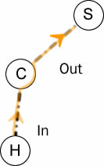
Figure 20: Charlottetown start

At this point there are 2 or more roads left to check. Traveling along an unchecked road leading into Edmonton or Charlottetown will trap the Mountie before checking all the roads. Therefore there is no way for the Mountie to check all the roads exactly once when starting in an even city. This means the Mounties route must start in Edmonton or Charlottetown. One possible route starting in Edmonton is illustrated below:

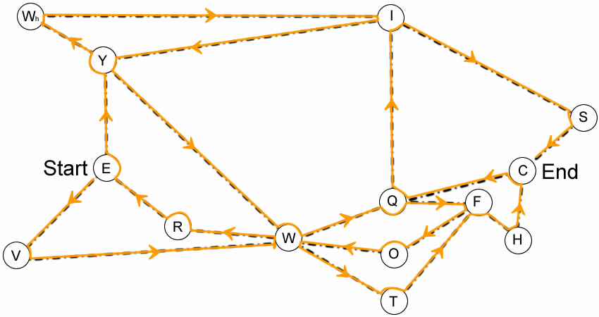
Figure 21: One solution to the extension
How many routes are there?

Notice when starting in Edmonton, the Mountie cannot get trapped in Edmonton. In addition, the Mountie cannot get trapped in any even city; since every time the Mountie goes into an even city there is an unchecked road leading out of that city. In conclusion, the Mounties route will always be successful if the Mountie starts in Edmonton and checks all the roads before the second visit to Charlottetown. For this reason there are hundreds of other routes.

In current mathematical research the problem of finding all such paths in every graph is still unsolved.

Summary
A healthy dose of competition will bring energy and excitement into your classroom. Not only is this game fun, but the strategies lead into very interesting mathematics. Winning games against your students should not be so much fun. But it is. The benefits of playing mathematical games in class include creating a positive atmosphere for exploration. The Horizon Report (The New Media Consortium, 2012) considers gaming to be part of the future in K-12 education. Playing this game with your students will make you a leader of innovative practices.
Make sure you let the students take home a copy of the game board to challenge their parents. They will relish in knowing how to beat their parents and siblings every time.

References

Alberta Education. (2007). Mathematics: Kindergarten to grade 9. Alberta Government. Retrieved from http://www.education.gov.ab.ca/k%5F12/curriculum/bySubject/math/Kto9Math.pdf
The New Media Consortium. (2012). NMC Horizon Report 2012 K-12 Edition. Austin, TX. Retrieved from http://www.nmc.org/publications/2012-horizon-report-k12
Wikipedia contributors. (2012, May 2). Bill Miner. Wikipedia, the free encyclopedia. Wikimedia Foundation, Inc. Retrieved from http://en.wikipedia.org/w/index.php?title=Bill_Miner&oldid=490383952

Appendix

